

**Satellite Imagery**

assisting in

**Crop yield Prediction**

Observing Satellite Images with human eye 

Following are satellite images of **2** places on the planet,

The Amazon Rainforest, and

The Sahara Desert



We (humans) can easily tell by **looking** at both the images, which place is which.

The greener the place is, more likely it is for a crop to grow and sustain.

**“greenness measurement” **

There are various indices used to calculate various metrics from the satellite image data.

One such index is used to determine the **greenness**. This index is called **Normalized Difference Vegetation Index**.

Calculation of NDVI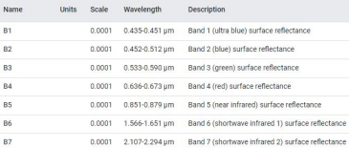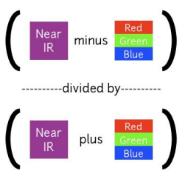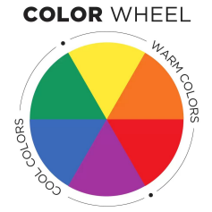

Value of NDVI can range from -1 to +1 **+1** being very green

**-1** being not green (red)



★ Therefore, we collect satellite image data of the input coordinates. ★ We determine/measure the “greenness” of the area.

★ We provide this **greenness measurement (NDVI)** to the ML model. ★ ML model does its job and gives the final crop that can be grown